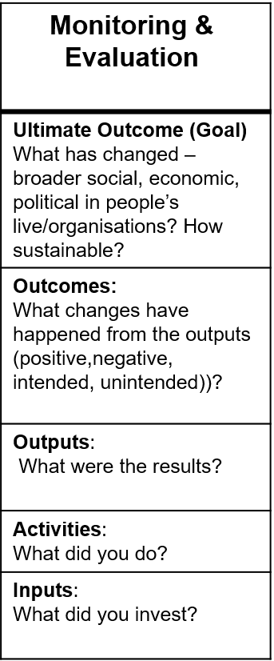
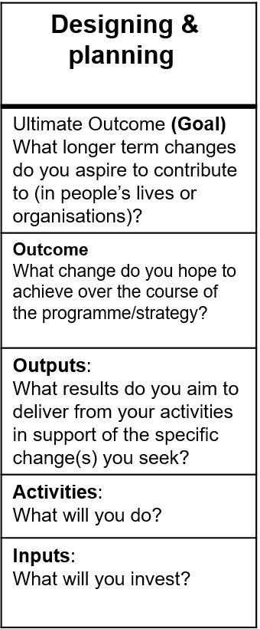
Review
Evaluation
Impact Assessment
Evaluation
Levels of results
Levels of objectives
Monitoring

